|  |  |
| --- | --- |
|  | The SSE/OPS Quick-Reference Guide provides a step-by-step technical guide for how to plan for, install, and use Shore Side Electricity (SSE), with a focus on Onshore Power Supply (OPS). It provides pointers for all port stakeholders to help bring SSE/OPS from the drawing board to the berth, and from the plan to the plug. Developed by EMSA in close cooperation with ESPO and experts from port authorities and the wider port sector, this *vademecum* document is based on the gathered experience in European ports on how to best introduce shore-power for ships at berth/OPS. Together with the EMSA SSE Guidance, the contents of the present *vademecum* cover the key steps needed to introduce safe, cost-effective, and future-proof OPS in the port. |

**WHAT WILL THIS GUIDE TELL YOU?**

High level Baseline Best Practices in the preparation, implementation, and control of Shore Side Electricity infrastructure projects

**WHO DOES THE PRESENT GUIDE ADDRESS?**

Port Authorities and Port Administrations

and other stakeholders interested in SSE development operation)

**KEY DEFINITIONS**

* **OPS**: Onshore Power Supply – the supply of electrical power to ships at berth, directly to the receiving ship, from a shore-side electrical power source, at a given voltage and frequency, feeding the onboard main distribution switchboard. OPS replaces primarily the onboard electricity generation from auxiliary generators.
* **SBC**: Shoreside Battery Charging – Charging of onboard Battery Energy Storage Systems (BESS) by shore power supply, either AC or DC, using a connection protocol suitable for the specific BESS onboard, at a specified charging power.

**1. GENERAL** The diagram below identifies the key infrastructure elements for SSE, OPS and SBC arrangements. The key elements are identified from a generic perspective. Electrical power infrastructure can follow a variety of different architecture layouts. The legend identifies the key infrastructure/equipment elements:

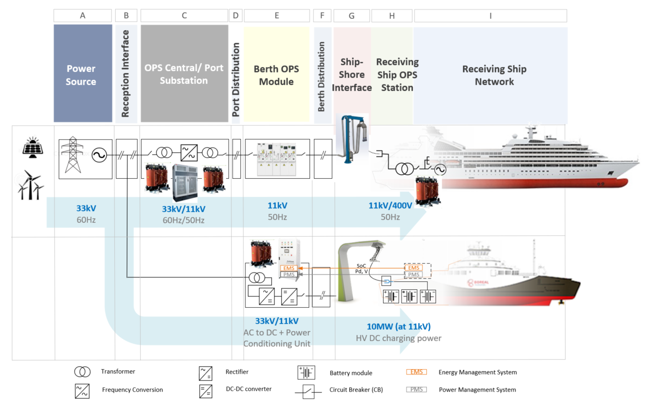

**C. OPS Central/ Substation** – including Step-Down Transformer, Frequency Converter, Main Circuit Breaker and Earth Switch

**A. Power Source** - A shore connection system can be supplied either from the national grid or a local port internal distributed energy system, through a power frequency conversion or not, depending on the application.

**B. Reception Interface** – Connection of the Port Grid to the external upstream utility grid. Electricity custody transfer

**E. Berth OPS Module** – Local OPS Module, close to supply point at berth – Shore-side protection transformer, Frequency Converter. Step-down/ Protection Transformation for required ship voltage supply.

**H. Receiving Ship OPS Station**- Circuit breaker and onboard receiving earth switch. Where applicable (if ship’s voltage is different from shore connection voltage) an onboard transformer to adjust the high voltage electricity to the ship’s main switchboard voltage; this transformer is preferably located near the main switchboard in the engine room.

**D. Port Distribution Network** – Port-scale distribution (either above or underground)

**G. Ship-Shore Interface** - Shore-to-ship connection, interface, and control equipment (cable reel, sockets, communication and control wires, earth relays) – All mechanisms to ensure compatibility, connectivity and communication included in the interface.

**F. Berth Distribution Network** – Berth-scale distribution (close to OPS supply shore connection)

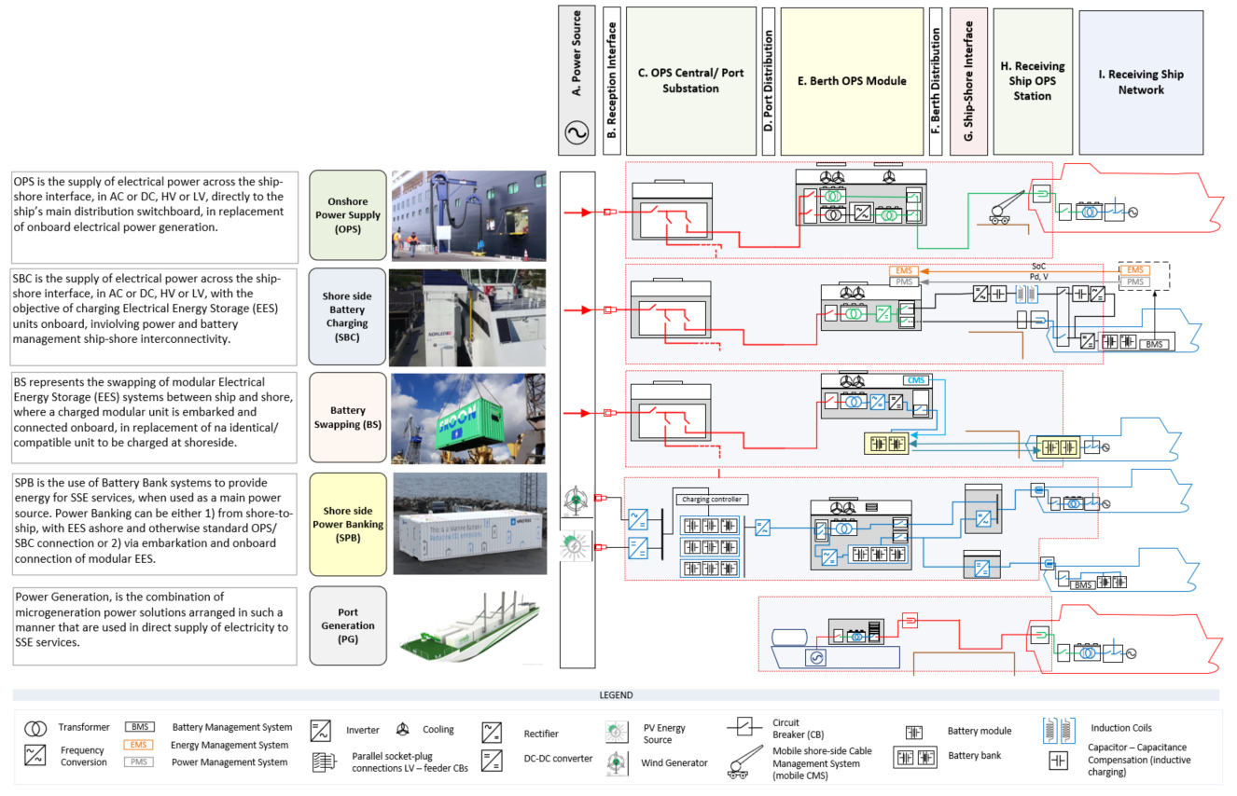

**2. SSE TYPES** The diagram below identifies different types of SSE arrangements. The key elements are identified in a generic arrangement and the actual situation will vary between ports, individual installations, and different user/operational requirements. Electrical power infrastructure can follow a variety of different architecture layouts. The legend identifies the key infrastructure/equipment elements.

**3. STAKEHOLDERS** Relevant Stakeholders can be identified playing a role in different stages of SSE infrastructure projects. These are presented below, in a non-exhaustive list. Central reference is made to the EU Regulation 2017/352 (Port Services Regulation), which includes within its scope the provision of shore-power in ports as a port service. Different combinations and port-specific arrangements are possible and both diagram and table below include generic references to possible stakeholders in SSE. As different port management arrangements are possible, it is important to adapt/interpret the table/diagram below with due consideration for this fact.

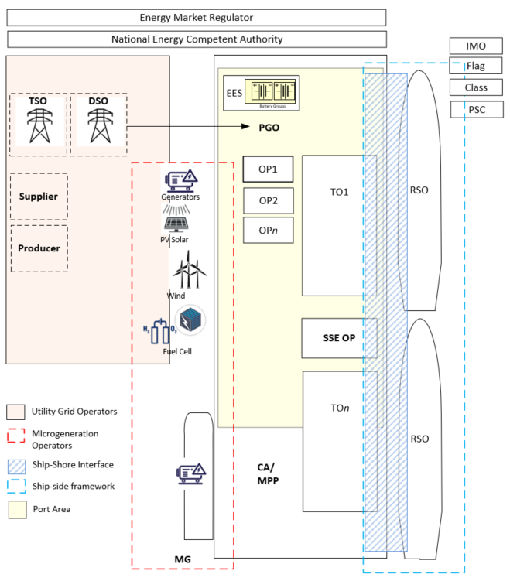

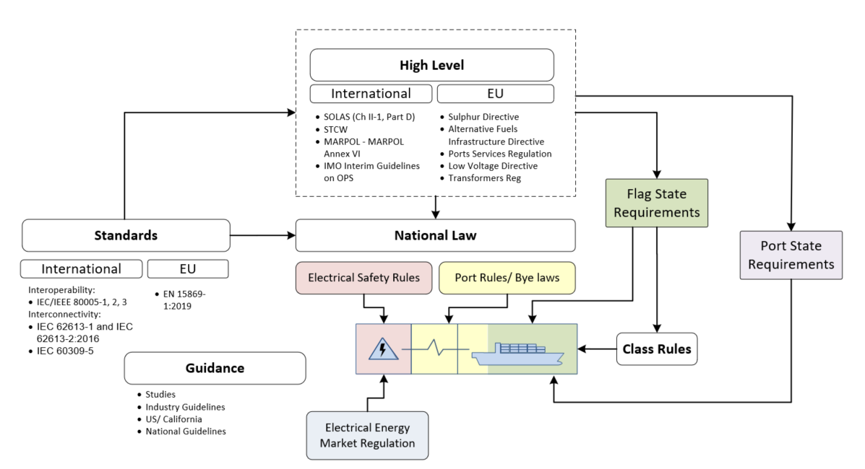**4. REGULATORY FRAMEWORK/ STANDARDIZATION** Regulatory Framework for SSE/OPS infrastructure project, development, and operation, needs to be assessed over the 3 dimensions: 1) Shore Side; 2) Ship-Shore interface and 3) Ship Side. High-Level instruments (International and EU), National Law (for Electrical and port regulatory aspects), Standards, Class Rules and Guidance documents, can be considered altogether the key building blocks for SSE Regulatory Framework. The diagram below provides a representation of the inter-relations between the different instruments. Standardization, for interoperability, interconnectivity and communications can be mapped in accordance with the table below.

The table below lists the different standards supporting Interconnectivity/ Interoperability and Data Exchange for different SSE types. The colour code indicates: 1) Green: standardization present/ existing reference; 2) Yellow: standardization not present but with possible close application of existing instrument and 3) Red: Still to be developed

|  |  |  |  |  |  |
| --- | --- | --- | --- | --- | --- |
| **SSE Type** | | **Interconnectivity** | **Interoperability** | **Data Communication** | **International/EU Regulatory** |
| **OPS**  (Onshore Power Supply) | High-Voltage Shore Connection (**HVSC**) | IEC 62613-1:2016 (General)  IEC 62613-2:2016 (Connector geometry/ dimensions) | IEC/IEEE 80005-1 (HVSC) | IEC/IEEE 80005-2 (Data Communication) | IMO OPS Guidelines  EU AFID |
| Low-Voltage Shore Connection (**LVSC**) | IEC 60309-5 | IEC/IEEE 80005-3  (under review/development) | IEC/IEEE 80005-2 | IMO OPS Guidelines already refer |
| **LVSC** – Inland Waterways (IW) | EN 15869-2:2019 (up 125A)  EN 16840: 2017 (above 250A) | | Possible application of IEC/IEEE 80005-2 | CCNR  CESNI – ES-TRIN2019 |
| Recreational Craft/ Marinas | IEC 60309-2 | Not standardized | Not standardized | Not relevant international standard applicable to |
| **SBC**  (Shore-side Battery Charging) | SBC-AC  (AC charging) | IEC 60309-5/ IEC 62613-2 AC connection  (As standard OPS connectivity) | IEC/IEEE 80005 series  As OPS – ship-side charging. | Not standardized  (possible development/ applicability for IEC/IEEE 80005-2 or ISO15118) | No applicable international regulatory instrument applicable to SBC |
| SBC-DC  (DC Charging) | Not standardized | Not standardized |

**5. IEC/IEEE 80005 series**: Below, the scope of the Internation Standard series IEC/IEEE 80005 is presented in relation to the main block elements of SSE infrastructure covered. The standard series are primarily scoped for OPS, with Part 1 dedicated to HVSC, Part 2 to Communications and Part 3 for LVSC.

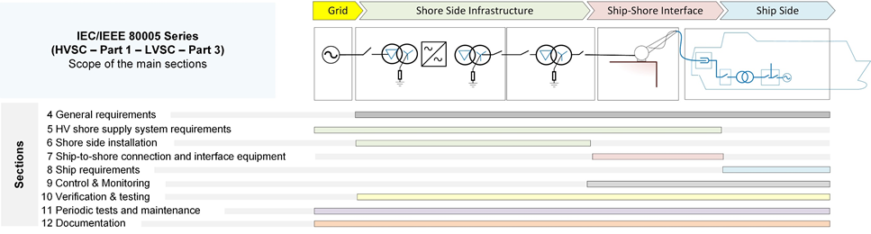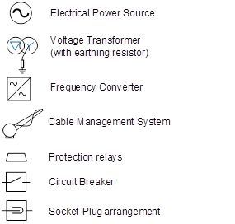

**6. SHIP TYPES** Power demand and ship-specific standards for interconnectivity and interoperability are presented in the table below.

|  |  |  |  |  |  |  |
| --- | --- | --- | --- | --- | --- | --- |
| Ship Type | GT | Voltage  (kV) | Power Demand  Average (Peak), MW | IEC/IEEE Standards  (Operability); Connectivity | | Power Demand drivers/ Operating Profile/ Safety |
| LVSC | HVSC |
| Oil tankers | <5,000 | 0.4/0.44/0.69 | 4 (6) | (80005-3 - annex-D)  IEC 60309-5 | (80005-1 - annex-F)  62613-2 - annex I | Power demand driven by cargo pumps and auxiliary systems.  (majority of oil tankers use steam driven pumps/systems)  Hazardous Areas in the ship-shore interface challenge the use of SSE.  Critical safety and reliability of SSE during cargo operations. |
| <10,000 | 0.69/6.6/11 | 6 (8) |
| >10,000 | 0.69/6.6/11 | 8 (10) |
| Chemical/product tankers  Ship Boat Silhouette - Free vector graphic on Pixabay | <5,000 | 0.4/0.44/0.69 | 6 (9) | (80005-3 - annex-D)  IEC 60309-5 | (80005-1 - annex-F)  62613-2 - annex I |
| <10,000 | 6.6/11 | 9 (12) |
| >10,000 | 6.6/11 | 10 (20) |
| Gas tankers  Lng Carrier Ship Silhouette Transparent PNG &amp; SVG Vector | <5,000 | 0.4/0.44/0.69 | 5 (8) | (not defined)  IEC 60309-5 | (80005-1 - annex-E)  62613-2 - annex I | Cargo pumps and auxiliary systems drive the load.  Critical system reliability during cargo pumping operations. |
| >5,000 | 6.6/11 | 9 (12) |
| Bulk carriers  Black silhouette of cargo ship Royalty Free Vector Image | <50,000 | 0.4/0.44/0.69 | 0.5 (0.7) | (not defined)  IEC 60309-5 | (80005-1 - annex-E)  62613-2 - annex I | Cranes, where fitted, hydraulic systems and hatches operation. |
| >50,000 | 0.69/6.6/11 | 2 (2.8) |
| General cargo | <25,000 | 0.4/0.44/0.69 | 1.5 (3) | (not defined)  IEC 60309-5 | (not defined)  62613-2 – as appropriate | Cranes, where fitted, hydraulic systems and hatches operation. |
| >25,000 | 0.69/6.6/11 | 3 (5) |
| Containers vessels   | <10,000 | 0.4/0.44/0.69 | 1.5 (2) | (80005-3 - annex-C)  IEC 60309-5 | (80005-1 - annex-D)  62613-2 - annex I | Cranes, where fitted, hydraulic systems, hatches operation, refrigerated containers. Reduced space at quay due to cargo terminal cranes pedestals. |
| <50,000 | 0.69/6.6/11 | 2 (5) |
| >50,000 | 6.6/11 | 4 (6) |
| Ro-Pax vessels   | <20,000 | 0.4/0.44/0.69 | 2 (4) | (not defined)  IEC 60309-5 | (80005-1 - annex-B)  62613-2 - annex J | Predominant Hotels loads and displacement of vehicle ramps.  Short turn-around times at berth. |
| >20,000 | 0.69/6.6/11 | 5 (6.5) |
| Cruise ships   | <50,000 | 0.4/0.44/0.69 | 4 (4.5) | (not defined)  IEC 60309-5 | (80005-1 - annex-B)  62613-2 - annex H | Large Hotel load driving the power requirements .  Safety and Reliability of SSE is critical for operation |
| <100,000 | 0.69/6.6/11 | 9 (12) |
| >150,000 | 6.6/11 | 18 (20) |
| Offshore supply vessel   | <5,000 | 0.4/0.44/0.69 | 1 (1.5) | (80005/3 - annex-B)  [IEC 60309-5] | (not defined)  62613-2 – as appropriate | Load from hydraulic systems, possible refrigerated module connections. modest hotel load. |
| >5,000 | 6.6/11 | 2 (3) |
| Fishing vessels | <5,000 | 0.4/0.44/0.69 | 0.5 (0.7) | (not defined)  IEC 60309-5 | (not defined)  62613-2 – as appropriate | Refrigerated systems and possible hydraulic/cranes operation |
| >5,000 | 6.6/11 | 2 (3) |

**7. POWER DEMAND** One of the key design variables to consider in the project for any SSE installation in a port is the estimated Maximum Power Demand at berth. This calculation should be performed with consideration to the yearly operating profile for a given port, considering the different types of ships requiring shore-power. A possible 5-step procedure for calculation of the estimated maximum power for the SSE installation is briefly presented below.

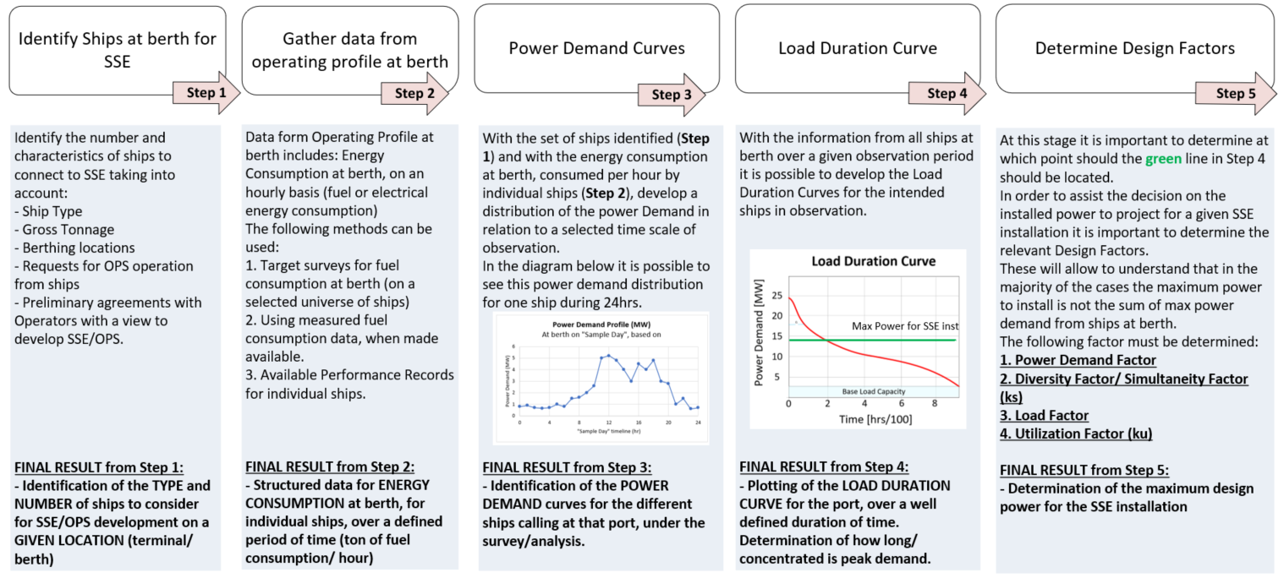

**8. RISK ASSESSMENT** SSE projects represent important realisations of electrical engineering, at Low-Medium-High voltage, and infrastructure. They are characterised by a system which operates on a complex multi-interface context (Utility Grid/Port Grid + Port Grid/SSE Shoreside + SSE Shoreside/Ship), where compatibility, interconnectivity and interoperability are essential safety building blocks. Safety has to be regarded for SSE projects with the earliest possible overview and identification of system-specific hazards, typically at the Planning and Design stage. At this point it is important to have a general overview of hazards to address and general safety risks to be mitigated, taking into consideration the known onsite conditions, equipment, and anticipated user-requirements/conditions. Early Risk Assessment should then be revised and updated at the Detailed Design stage and prior to construction/integration.

Safety Risk Assessment should include a Criticality and Reliability analysis (e.g., FMECA). Several instruments, methodologies and standards may be used for the realization of the Safety Risk studies. Important aspects to ensure should be: 1) that a recognized methodology is applied, 2) an independent risk consultant is involved (ideally the same for the different stages), 3) that all evidence is documented and made available for detailed engineering drawings, integration, and construction.

**FAILURE MODE SCENARIOS**

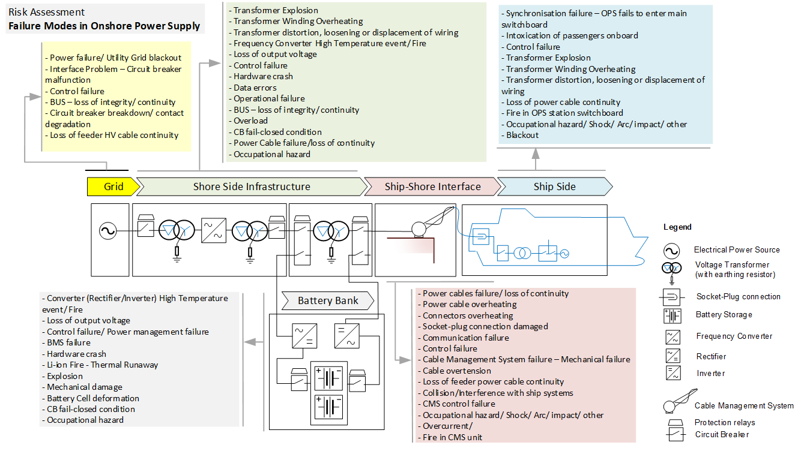The Identification of the different possible failure modes is the basis for all Risk Assessment studies/ analysis. The diagram below includes the main equipment blocks of a standard SSE/OPS system with Electrical Energy Storage/ Battery bank associated for Grid stabilization or as Power Supply continuity. The identification of the failure scenarios should follow the project development from the very early concept stages and should include the widest possible range of stakeholders involved. It is fundamental to acknowledge that Risk Assessment is always an open exercise which needs to be re-assessed for every new ship applying for a 1st Connection.

**BOW-TIE REPRESENTATION OF SSE BLACK-OUT**

Below is presented an example of a Bow-tie diagram representing causes and consequences in relation with a SSE supply blackout.



**9. LIFE CYCLE PLAN** The figure below identifies the different Life Cycle steps for SSE projects. Overall, the process is divided into 4 main stages: Preparedness, Planning and Design, Engineering/ Procurement/ Contracting/ Construction and Operation. Within these 4 main stages the structure presented follows the typical engineering development process, with 1) identification of initial requisites, 2) Study of options followed by 3) Feasibility Analysis and Project Evaluation. Following the identification of a preferred option the deployment of the project takes place with all detailed engineering drawings, procurement, contracting and construction and finally the Operation of the system. The structure below should not be understood as a rigid construction but rather as a *good practice* based on the structured engineering project development. Specific aspect of the Shore Side Electricity context are to be however highlighted, such as the establishment of a collaborative environment, corresponding to Step “A”. This step is one that should be understood as taking place irrespective of a specific decision for project development.



**10. OPERATION** The process diagram for both OPS and SBC are presented below.

|  |  |  |  |
| --- | --- | --- | --- |
| **Onshore Power Supply (OPS) –** synchronised transfer | | **Shoreside Battery Charging (SBC) – DC Charging form shoreside with** | |
| Connection Procedure | Disconnection | Connection Procedure | Disconnection |
| Initial State - disconnected  Compatibility Assessment (1st Visit)  connection  Safety check & Cable  connection  Shore substation start order  Synchronization of ship generator  Coupling of Ship Power System to shore SSE substation  Ship genset ramp down to transfer the entire load on shore substation  Disconnection of ship generator | Safety check and cable disconnection  Shore substation shutdown order  Ship generators ramp up to transfer entire load to ship generator  Connection of ship generator  Synchronization of ship generator | Charge  Pre-charge  Cable check  Initialization  Compatibility Assessment (1st Visit)  connection  Connection  Initial State - disconnected | Power Down  Disconnection |